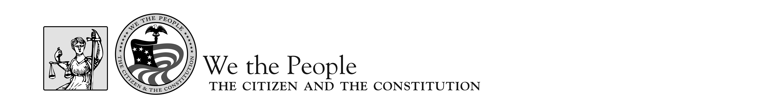

Event Schedule—National Finals 2017

FRIDAY, APRIL 21
All Day Arrivals
4:15–4:45 p.m. Facilitators’ Orientation Belmont Room- West Building
5:00–6:00 p.m. Floor Supervisors’ Orientation Belmont Room- West Building
5:00–7:00 p.m. Judges’/Facilitators’ Orientation Potomac Room- West Building
6:30–7:00 p.m. State Coordinator Meeting Belmont Room- West Building
7:00 Informal Reception- Cash Bar Black Olive- North Building

SATURDAY, APRIL 22
9:00 a.m.–7:20 p.m. Competition Hearing Sessions North Building- NCC

SUNDAY, APRIL 23
9:00 a.m.–7:20 p.m. Competition Hearing Sessions North Building- NCC

7:30 p.m.-9:30 p.m. Student Dance NCC- West Building -Ballroom
9:15 p.m. Announcement of Top Ten Finalists NCC- West Building- Ballroom
9:30 p.m. Meeting of Finalist Teachers/Coordinators NCC- West Building -TBD

MONDAY, APRIL 24
10:00 a.m.–1:00 p.m. Competition Hearing Sessions: Finals Capitol Hill, Washington, D.C.
2:00–5:00 p.m. Capitol Hill, Washington, D.C.
8:00–10:00 p.m. Awards Ceremony NCC- West Building -Ballroom

TUESDAY, APRIL 25
All Day Departures

